Racoon 101: Basics

"if you are here in error, the airlock is on the sub level, port side."

**Notes to instructors:**

1. You need a carrack. If you don't own one, borrow one, find someone on OPFOR who owns one, or bring a friend along. You need a carrack to run this training. You could use an 890 if you own one, but don't own a carrack, but plan to teach everyone the route to/from the medical office.
2. take notes on the students, keep track of those who need to retake the course, *and why*.
3. OPFOR must have taken this course before they can be OPFOR.
4. bring color coded flares. throw them behind cadets who need "special attention"
5. Training site:

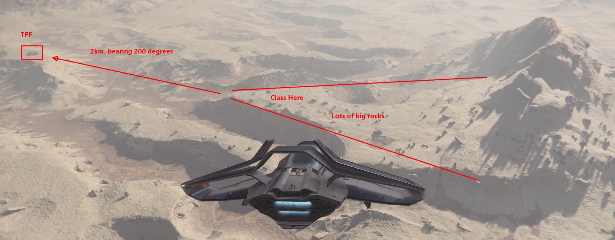

| **Course Element** | **Target Duration** | **Description** | **TODO** |
| --- | --- | --- | --- |
| Instructor briefing |  | 1. Do not wear racoon armor to the training (*e.g.* white morozov, etc.) 2. Significantly disruptive or uncommitted cadets should be asked to leave the party and training site immediately. |  |
| Cadet Homework | --- | 1. what kit to buy (black armor, p4s, 20x mags, etc.) 2. videos to review (quiz cadets on them during lulls) 3. review super-basics (key binds, movement, etc.) | identify the before-minimums to know and create a pre-basics sheet |
| OPFOR briefing | --- | review the class schedule, rules of engagement, and goals of the training to the OPFOR. ensure they understand this isn't *carte blanche* to shoot at students. they're partially responsible for the instruction. they are more like storm troopers than proper raccoons. must wear non-racoon armor. have fun with that. and *strongly encourage energy weapons* to increase the students' ability to identify them. |  |
| **CRU-L1 LOBBY** | 20 mins | *prepare the cadets for class and departure* |  |
| Muster |  | 1. right time, right place, right attitude. 2. inspection |  |
| Briefing |  | "when you leave this class, you will be able to:"   1. complete a team fps mission successfully 2. **move and communicate as a small unit** 3. you fight as individual, but you win as a team 4. know how much you don't know about fps combat in star citizen 5. understand raccoon training opportunities 6. know how to join a task force   "there are important skills you need but that we will not cover today. we cover these topics in other raccoon courses and we hope you take them, too."   1. medical tools and techniques 2. fighting with and against vehicles 3. using snipers and heavy weapons 4. breaching doors and airlocks 5. combat zone ingress/egress 6. ship layout familiarization 7. zero-G movement 8. combat engine mechanics |  |
| **TRAVEL** | 10 mins | *depart CRU-L1, fly to Daymar / TPF* |  |
| Embark |  | 1. get aboard 2. get imprinted at medical 3. ask *someone else* to fly so you can focus on talking. |  |
| Teach Comms & Discipline |  | 1. **comms**, stand still, listen, don't mess with weapons during class, etc. 2. the more people, the less you should talk 3. abandon "me"/"I" for class. we don't know each other or voices 4. communication and coordination is the majority of raccoon-ing |  |
| Teach: Unit Organization |  | 1. principle of doubling so half can support half 2. pair/fire team, squad (four), team (eight), etc. 3. get cadets into pairs and squads here. 4. chain of command 5. handling casualties |  |
| **DAYMAR, SURFACE** | 30 mins | *quantum to TPF, put the bunker at 200º, 2km out, land* |  |
| ~~Teach: Weapon control~~ |  | 1. ~~aim-down-sights~~ 2. ~~leaning~~ 3. ~~crouching~~ 4. ~~proning, and its difficulties~~ 5. ~~adjusting run speed using mouse wheel~~ | Move into homework section. |
| Teach: Orientation |  | 1. path of movement/facing 2. clock points 3. common points of reference 4. don't neglect distance 5. describing objects (size, shape, color, equivalence, etc.) 6. "on my fire" – relates to weapon selection |  |
| Teach: Bounding (*quickly!*) | ~5 mins | discuss method, value, have squads practice very quickly while OPFOR is getting into position. demonstrate with an assistant instructor or member of OPFOR as a partner. |  |
| Exercise: Outdoor | ~20 mins | outdoor, approx. 200m engagement with OPFOR, light-to-moderate cover  goal: far-distance, team, coordinated, tactical, king-of-the-hill-like skills |  |
| ACE reports | ~3 mins | ammunition, casualty, equipment. green, amber, red. reminder that status includes oxygen, nutrition, hydration, and temperature, too. practice. |  |
| Patrol | ~10 mins | marching order, facing, spacing, keeping team direction  move overground from training site to TPF. teach spacing using an atzkav rifle on the cadets closest together. |  |
| Teach: Environment |  | 1. visibility: cover, concealment, and color (what's behind you?) 2. environmental conditions    1. temperature    2. oxygen    3. food/water    4. visor wipe (fixes almost everything)    5. wind, dust, snow, etc. |  |
|  |  | opfor moves the carrack to the bunker |  |
| **DAYMAR, BUNKER** | 60 mins | *clear TPF of AI, clear TPF of OPFOR, defend TPF from hunters* |  |
| Exercise: CQB PvE  (*if* the baddies spawn) | ~10 mins | simulate a team bunker mission. cadets methodically clear enemies from bunker, focusing on lessons, communication, facing, callouts, and coordination – *not speed.* if no NPCs are available, have the OPFOR act like NPCs (patrol slowly, react slowly, etc.). |  |
| Exercise: CQB PvP defense | ~10 mins | OPFOR simulate bounty hunters attacking raccoons in a bunker. cadets take defensing position beyond the first steps down. OPFOR enters from elevator. optional. discard this element if the course is running long. |  |
| Exercise: CQB PvP attack | ~10 mins | cadets leave the bunker. OPFOR take defensive positions. recommend two on the non-entry level, and one hiding near the entry with goal to let cadets pass and attack from behind. cadets clear the bunker again. increase challenge level for this exercise. |  |
| **CARRACK** | 10 mins | *en route back to CRU-L1* |  |
| Embark |  | Everyone back on the carrack |  |
| Debriefing | ~20 mins | Hold this aboard ship, en route back to the station.   1. Go around circle. Ask everyone to say something they learned and something they plan to practice after this class. Everyone participates. 2. review how to join a task force 3. review raccoon curriculum and how to advance |  |
| Teach: Racoon curriculum |  | different levels, take in any order, finish all in level to advance. remind about 103 requirement next. |  |
| Teach: join a task force |  | yellow taskforce category with descriptions and times for each. contact information inside each. |  |
| Invitation to be OPFOR |  | fun, opfor request channel, etc. |  |
| **CRU-L1 LOBBY** | 3 mins |  |  |
| Team Photo |  | team photo |  |
| Cadets who fail to absorb the material |  | Discuss discreetly with cadets who need more coaching to succeed. Must be able to give specific feedback, skills to grow, and how to do it. Note in course record "recommend to repeat course" and note which skill next instructor must watch. |  |
| Paperwork! |  | 1. Never forget the paperwork. Post in the #racoons channel a congratulations message with the team photo and the names of the graduates. 2. Update the training records spreadsheet with the students and course completion date. |  |

| Bonus content if time permits |  |  |  |
| --- | --- | --- | --- |
| Teach: Known Bugs & Workarounds |  | 1. empty mag reload 2. female model scope hit height bug 3. weapon won't stay in hand bug 4. visor wipe to fix almost (?) everything 5. knockout+tractor when trapped | Update as game changes  add to homework pamphlet |

**major points:**

1. discipline
   1. **comms**, stand still, listen, don't be messing with weapons during class, etc.
   2. the more people, the less you should talk
   3. abandon "me"/"I" for class. we don't know each other or voices
   4. communication and coordination is the majority of racoon-ing
2. kit
   1. what is the "standard" raccoon load-out and why
   2. weapons (intro) selection and consequences
      1. why chose weapon categories
      2. effective and max range
      3. damage falloff
      4. shot dispersion, recoil
      5. acquisition time, reload time
   3. armor & gear (non-weapons) selection and consequences
      1. invulnerable gear
      2. stamina, weight, and speed
      3. how many mags for a fight? (they're heavy!)
      4. damage reduction
      5. attachment counts (ammo, grenades, etc.)
      6. equipping weapons and ammo
   4. medical
      1. red med pens, med guns (auto mode)
      2. equipping things on your leg
      3. injuries and tiers
      4. med beds on ships (cutlass, carrack, 890)
3. unit organization
   1. principle of doubling so half can support half
   2. pair, squad (four), team (eight), etc.
   3. chain of command
4. communicating direction, common points of reference, describing objects, etc.
5. environment
   1. visibility: cover, concealment, and color (what's behind you?)
   2. environmental conditions
      1. temperature
      2. oxygen
      3. food/water
      4. visor wipe
      5. wind
   3. movement: leaning, proning, run speed using mouse wheel
   4. common fps bugs and workarounds
      1. empty mag reload
      2. female scope height bug
      3. weapon won't stay in hand bug
      4. visor wipe to fix almost everything?
6. "work in pairs"
   1. recruits in pairs against each other a few times
   2. running pairs again OPFOR (one or two?)
7. something against OPFOR?
   1. close-distance, individual, technical, quick play, whetstone-like skills
   2. far-distance, team, coordinated, tactical, king-of-the-hill-like skills

thoughts:

1. two hours MAX (keep this class to 90 minutes if possible, as it has grown to be a three hour beast in many cases. 15 min travel/intro + 90 min class + 15 min travel/wrap = two hour class)
2. perhaps fewer than 8 students?

**elements we can drop are:**

- movement formations

- suppressing fire

- bounding, assaulting, and shifting fire

**elements we should hit are:**

- pre-departure gear check (mag count, weapon choice, etc.)

- basic gear loadout

- basic weapon type overview (purpose and value)

- team IDs and communications (e.g. "one moving")

- comms discipline

- directional callouts – where is the enemy?

- movement with a partner – staying together, covering each other, safe distance

- chain of command in case of casualties

- post fight ACE check, atmo, oxygen, food, water, gear refresh

- a quick outdoor firefight (~200m engagement, <20 min)

- a quick indoor firefight (~20m engagement, <20 min)

- debrief: what did we each learn?

- discuss how raccoon curriculum works (200 courses, etc.)

- how to join a taskforce

- team photo

idea: present raccoon students with homework before class. the before-minimums they need to know. videos to watch, gear to buy,